Farewell Message

Let me begin by saying ‘Happy Easter!’ Happy Easter to you and yours!

Easter is principally a day and time of celebration, the celebration of Christ’s resurrection from the dead and a focus on new life and new beginnings, especially as we move away from the dark and cold of winter towards the brightness and warmth of Spring and Summer.

Yet we may be feeling a variety of different things today, living in these rather strange times. I certainly am, as Easter Sunday also signals the end of my ministry here in St Thomas and, in a few weeks, the beginning of a new ministry in the Royal Navy. I feel sad at leaving such a lovely community as this but yet also a sense of excitement too - and if I’m honest a slight degree of nerves - as I follow God’s call into a new and very different way of being a priest.

Although we understandably and rightly live with our current restrictions to curb the spread of the Coronavirus certain things are unrestricted, amongst them, I feel, are memories and linked with those memories a sense of thankfulness too.

In my time here at St Thomas we went through thick and thin together and, as with life, there were great days, challenging days and everything in between; but I will remember you all and my time here with a smile and a feeling that we shared together and showed together something of God’s love here in this place.

Who knows what the future looks like in these strange times but even if we don’t get the chance to meet together before my departure I will hopefully return to see you at some point.

I n the meantime, I wish you all the very best both individually and as a community. Look after yourselves and each other and thank you, thank you for the love and support you have shown me and my family and for all the good times that we have shared together.

God bless you all and I’m sure I’ll see you all again soon and once again a very ‘Happy Easter’ to you all.

Fr Charles

PRAYING OUR FAREWELLS (Adapted from the Anglican Franciscan Order)
Spend a moment or two saying quietly what you have appreciated in Charles’ ministry and how you might wish him well in his new adventure.

God of our beginnings and endings,
we celebrate all we have shared with Charles
and ask your blessing as he continues on his journey.
May the love that is in our hearts
be a bond that unites us forever,
wherever we may be.
May the power of your presence
bless this moment of our leave-taking;
this we ask for the sake of Jesus Christ, our Redeemer. Amen.
I thank my God, every time I remember you, constantly praying with joy for all of you, because of your sharing in the gospel. And this is my prayer, that love may overflow more and more with knowledge and full insight to help to determine what is best, so that in the day of Christ we may be pure and blameless, having produced the harvest of righteousness that comes through Jesus Christ for the glory and praise of God. Philippians 1. 3, 4, 9
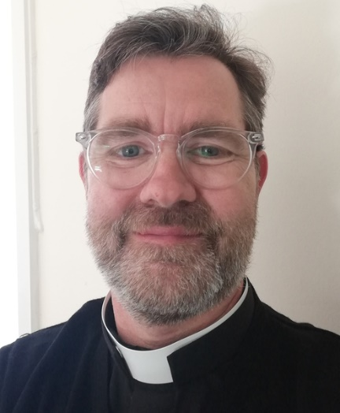
The Officiant then says,
We praise and thank you, God of the journey,
for our brother Charles who is soon to leave us.
We entrust him into your loving care,
knowing that you are always the faithful traveller
and companion on the Way.
Shelter and protect him from all harm and anxiety.
Grant him the courage to meet the future,
and grace to let go into new life;
through Jesus Christ our Saviour. Amen.
Charles, may God bless you. Amen.
Go in peace, for our God goes with you.

www.franciscanarchive.org.uk/b-tdossfsupplement.html

